Observation 1:

As a recruiter after posting a job, job is posted but its redirecting to blank page and no pop up is displaying to confirm that the job has been successfully posted.

Recruiter’s job posting page:

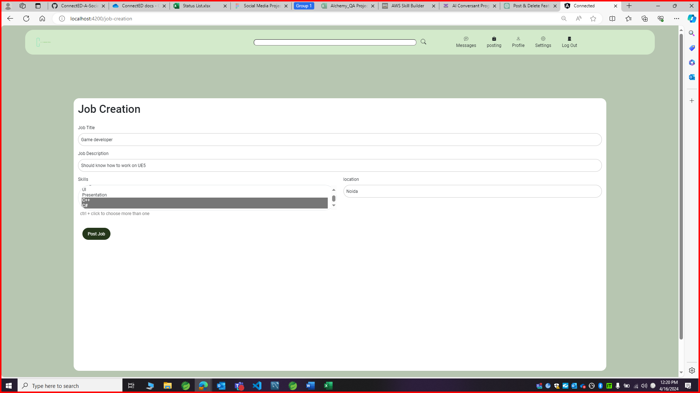

After posting job:

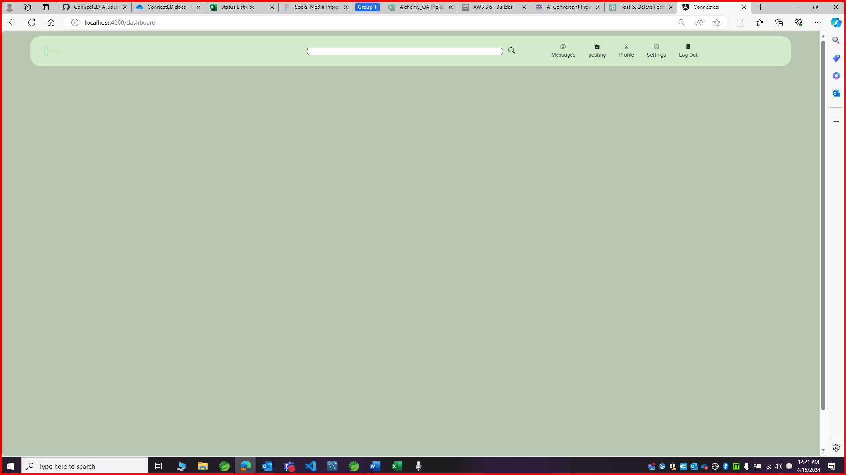

Observation 2:

As a recruiter in the job posting page, location field is accepting digits and there is no error displaying for that and its allowing to post the job with the same details.

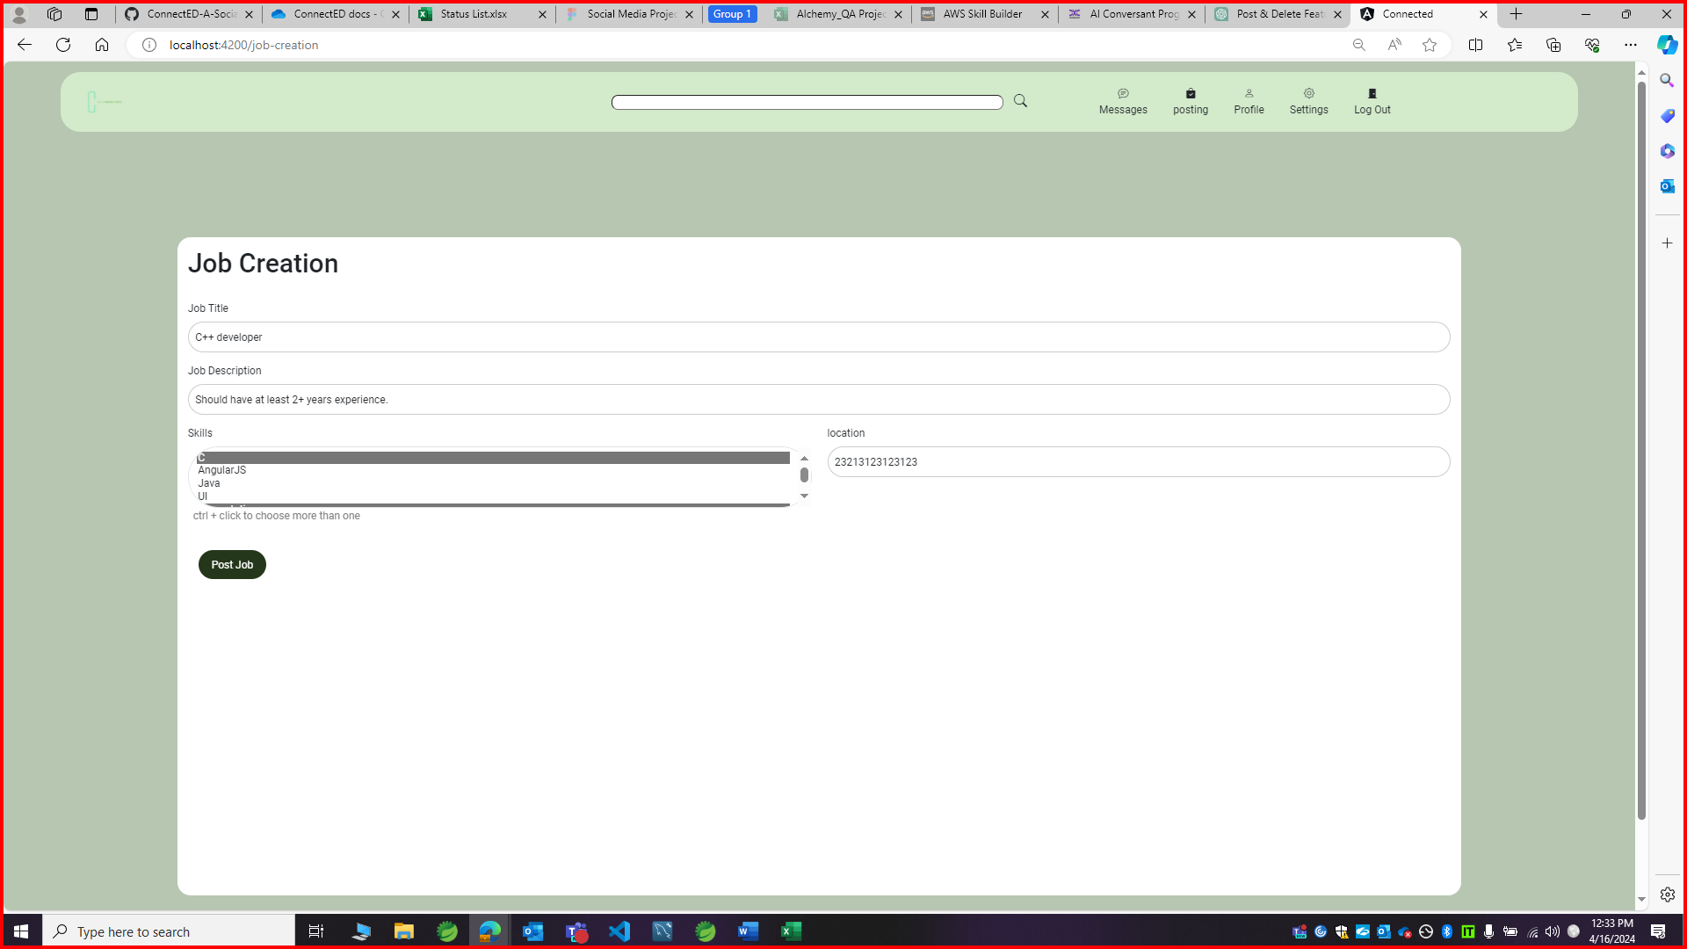

Observation 3:

There is no title in the user’s job page stating that we are currently in that page.

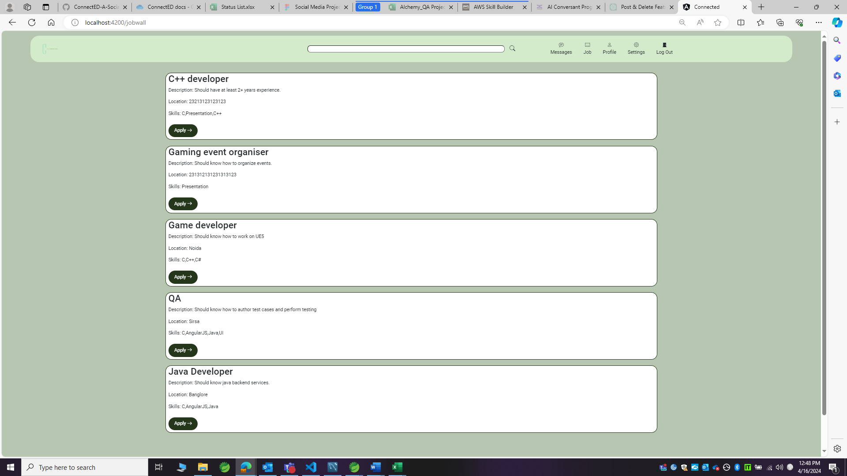

Observation 4:

Skill is not displaying in the profile page. (reproducing for all roles).

Recruiter profile page:

